

Complaints Policy

Version 1.1
Date: September 2024

SC015451

Introduction:-
Devana Parish Church, being part of the Church of Scotland, seeks to ensure that the Church is a safe, responsible and caring environment for all. To achieve this, the Church of Scotland has put rules and procedures in place to enable our Kirk Session to deal with any acts of inappropriate or unethical behaviour by any Church minister, deacon or office bearer.
These rules differentiate between serious issues of conduct, and other acts of inappropriate behaviour. For serious issues, the Church of Scotland has internal disciplinary procedures. In some circumstances, it may be appropriate to refer the matter to the Police, if the complainer has not already done so.
For less serious matters, the Church of Scotland has a Complaints Procedure. The aim of this Procedure is neither to trivialise serious matters nor to treat minor matters with undue seriousness. In this Procedure, the Church of Scotland wishes to prioritise the use of mediation and conciliation, as experience suggests that this is the best way to ensure an outcome where everyone involved feels that their concerns have been appropriately discussed and dealt with.
In framing its Complaints Procedure, the Church has been strongly of the belief that a person with a legitimate grievance must be listened to and their complaint should be properly and fairly addressed.
Please note that the information which follows is for guidance only, and is not a substitute for the detailed law which appears in the Acts and Regulations of the General Assembly. These Acts and Regulations are available in Church Law.
If anyone has a complaint to make against a minister, deacon or office bearer of the Church, then there are various ways in which the Church may determine that it should be addressed, as illustrated in the following flowchart.

Possible ways in which a complaint may be dealt with:-
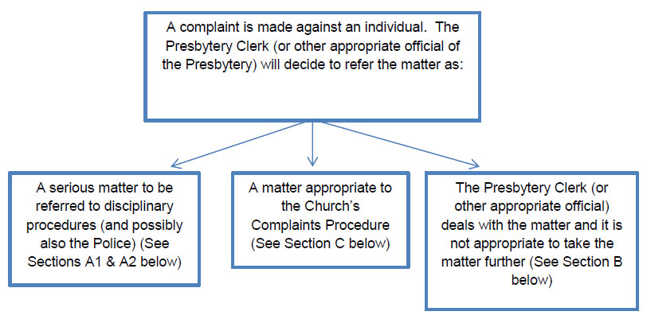

A1: Internal disciplinary procedures
If the allegation is a serious one, it will immediately be referred to be investigated in terms of the Church's internal disciplinary procedures. The individual making the complaint will be given information about the process which will be followed. This will differ depending upon whether the allegations are against a minister or deacon, or against an office bearer. The procedure may also differ depending on the nature of the allegations, for example if there are issues of bullying or discrimination and depending upon whether the person is an employee of a local or central agency of the Church.
If the matter is dealt with under disciplinary procedures, then you may need specialised advice. This may be available from the Presbytery Clerk, or the Principal Clerk. Further details will be provided on an ongoing basis in this situation.
Disciplinary proceedings may ultimately lead to a censure being imposed on the respondent (ie the person who is the subject of the complaint). In the case of a minister or deacon, this may consist of a reprimand, suspension for a fixed period or without limit of time, or removal of status as a minister or deacon. In the case of an office bearer, the Presbytery may decide to give an instruction regarding future conduct, issue a reprimand, remove the person from office or deprive them of status.

A2: Referral to the police
In some circumstances, it may be appropriate to refer the matter to the Police, if the complainer has not already done so. This will be where criminal behaviour is alleged, in particular where there are allegations of a serious sexual nature, where vulnerable groups are involved or where allegedly there has been financial impropriety. Anyone who becomes aware of offending of this nature is urged to contact the Police immediately.
Whether or not a minister, deacon or officer bearer of the Church is found guilty in a civil or criminal court of law, they may still be proceeded against under Church law. Where an investigation has already commenced under Church law but it then becomes apparent that the Police are involved, it would be normal for any internal Church investigation to be suspended until a Police investigation has been completed.

B: Matter not to be taken further
In some cases it might be determined at an early stage that the allegations do not require further consideration or investigation. A conversation with the Presbytery Clerk or other Presbytery official may well have been enough to allay your concerns or to establish that the matter does not require further investigation. However, normally the matter will be referred to the Church's Complaints Procedure.

C: The Church's complaints procedure
A matter which does not justify being referred to disciplinary procedures nor to the Police, and which has not been resolved at an early stage, will be referred to the Church's Complaints Procedure.

What is and what is not a complaint?

Examples of complaints
A complaint might be:
- An allegation about the conduct of a minister, deacon or office bearer or about the way in which they have performed their duties
- An expression of dissatisfaction about the way in which you have been treated by a minister, deacon or office bearer or about their attitude to you
- An allegation that a minister, deacon or office bearer has failed to do something in the way that should reasonably be expected
- An allegation that there has been unreasonable delay by a minister, deacon or office bearer in responding to an enquiry or request
- A breach of confidentiality by a minister, deacon or office bearer
What is not a complaint?
A complaint is not:
- a routine request for information or for an explanation of the way in which something is done. In the first instance, such an enquiry should be referred to your local Church officers. However, the Presbytery Clerk (see below) is a person who you can contact should you simply wish an explanation of the way in which the Church normally does something
- an allegation which is not about a person, ie it is about a court, Council or Committee of the Church. Such allegations will be dealt with under different Church procedures

What doesn't the Church's Complaints Procedure deal with?
The Church's Complaints Procedure is generally for allegations made against individual persons within the Church. Some things which the Church's Complaints Procedure doesn't cover are:
- An issue about selection or training of a minister: this goes to the Ministries Appeal Panel
- An issue about Presbytery planning (this is the Church's process for determining the extent and nature of congregations within the Church): this goes to the Appeals Committee of the Commission of Assembly
- An issue about insurance, sale or purchase of property: this would be dealt with by the Secretary of the General Trustees or his staff
- An issue about buildings maintenance: this would be dealt with by the appropriate local congregational body or Committee
- Insurance claims: these go to the insurance company
- An issue which involves a Church person but not a minister, deacon or office bearer etc: this will be referred straight to the local Kirk Session to be dealt with
- An attempt to reopen a previously concluded complaint or to have a complaint reconsidered where a final outcome has already been reached
- An issue which involves vulnerable people: this will go straight to Safeguarding procedures. For further information click here [Note: there will be a hyperlink here to a new web page in the web version]
Also, while you can complain about a matter which is already being dealt within the civil or criminal courts (such as the Sheriff Court, High Court of Justiciary, Court of Session or an employment tribunal), such a matter will not normally be dealt with by the Church until the civil or criminal process has been concluded.
Where the complaint should be dealt with under a different process, as mentioned above, the Presbytery Clerk will be able to supply you with the appropriate information about who to contact.

Making a complaint

Step 1: Who to contact about a complaint
The Church is divided into geographical areas, known as Presbyteries.
There are 38 of these in Scotland, plus Presbyteries for England, Jerusalem and the rest of the world. Each Presbytery has its own Presbytery Clerk. That person can support and advise anyone thinking of making a complaint regarding a minister, deacon or officer bearer of the Church. Find the Presbytery Clerk for your local area. To cover the situation where the complaint is against the Presbytery Clerk, this list will incorporate alternative contacts within each Presbytery.
You can email or telephone the Presbytery Clerk. Please always make initial contact with Presbytery Clerk in this way before following the more formal steps noted below.
If the person you want to complain about is the Presbytery Clerk, then please note that at the link above setting out contact details for each Presbytery Clerk, duplicate contacts are given in each case. In these circumstances you should contact the alternative person named for that Presbytery, who will be another Church official.
The Church hopes that wherever possible, initial discussion with the Presbytery Clerk (or other appropriate Church official) may well have been enough to allay your concerns or to establish that the matter does not require further investigation.

Step 2: Progressing a complaint – formal notification
If the matter is to be taken further, then the Presbytery Clerk must have some details from you in order for a complaint to be properly investigated. This means that you need to write to the Clerk, either in a letter or an email, setting out:
- who you are, plus your contact details,
- whether you are a Church member, or office bearer,
- exactly what the nature of your complaint is,
- exactly which persons - ministers, deacons or office bearers - you are complaining about, and
- specific details of the circumstances (including, where possible, names of individuals, places, dates etc)
The Presbytery Clerk can assist you with this. Upon receipt of your written complaint, the Presbytery Clerk will acknowledge this in writing within 7 days. All information which you supply in connection with your complaint will be treated sensitively. So far as is possible while still enabling your complaint to be properly dealt with, the information which you give will be treated confidentially.

Step 3: Dealing with a complaint
On receipt of your written complaint, the Presbytery Clerk will send it to the Convener of the Presbytery's Complaints Committee. A meeting of that Committee will then be called to consider the complaint.
Following the meeting of the Complaints Committee, one member of the Committee will contact you to discuss your complaint and if appropriate, to arrange to meet with you.
The Complaints Committee will also forward a copy of the complaint to the respondent (the subject of the complaint).
The Committee may similarly meet with the respondent. The Committee shall make such enquiries as it considers appropriate and may hold more than one meeting separately with you, the complainer, and with the respondent. If it considers this to be appropriate and both parties consent, the Committee may facilitate a mediated meeting between you and the respondent.
On any occasion where the Committee meets with you, you are entitled to have present two other persons; where there is more than one meeting, these will ideally always be the same two persons.
On any occasion when the Committee meets with the respondent, the respondent shall be entitled to have present his or her pastoral adviser and one other person; again where there is more than one meeting, these will ideally always be the same two persons.
Summary notes will be kept of all meetings throughout the process.
The Committee will endeavour to provide you with an initial response on your complaint within a period of 20 working days from when it first considered the complaint.

Step 4: The outcome
Upon completion of its enquiries, the Committee will hope to have achieved one of the following possible outcomes (although this list is not exhaustive):
- You as complainer are satisfied that the matters raised in the complaint have been resolved;
- You as complainer and the respondent have reached a mutual agreement that the matter need go no further;
- You as complainer and the respondent agree that the matter may be referred to mediation;
- The Committee will make a recommendation to Presbytery that the respondent be given an instruction or advice as to his or her future conduct,
- The complaint has been dropped or dismissed, or
- The complaint having been dealt with, the matter is, despite no agreement having been reached, nonetheless concluded
The Procedure outlined above is subject to a right of procedural review. Further information about this will be given to you if it applies

